Postal Life Insurance

Department of Post

Software Requirements Specification (SRS)/ Functional Requirements Specification (FRS)
  - Management of Audit of all Transactions

INTERNAL APPROVAL FORM

Project Name: Management of Audit of all Transactions
Version: 1.0
Submitted on:
 | Name | Date
Approved By:
Reviewed By:
Prepared By:

VERSION CONTROL LOG
Version | Date | Prepared By | Remarks
1

Table of Contents

1. Executive Summary 4
2. Project Scope 4
3. Business Requirements 4
4. Functional Requirements Specification 5
4.1 Audit Log Viewer Page 5
4.2 Reconciliation Dashboard Page 6
4.3 Anomaly Detection Page 6
4.4 Audit Annotation Page 6
4.5 User Access Log Page 6
5. Attachments 7

1. Executive Summary
This document outlines the requirements for implementing a comprehensive Audit Trail Management system within the Insurance Management System (IMS). The goal is to enhance transparency, accountability, and compliance by enabling full-spectrum logging, automated reconciliation, and real-time anomaly detection.

2. Project Scope
The Audit Trail Management module will track all user and system activities across IMS, including financial transactions, manual overrides, reversals, and audit annotations. It will support real-time dashboards, alerts, and role-based access to ensure secure and efficient auditing.

3. Business Requirements

ID | Requirements
FS_AT_001 | The system shall log all financial transactions including manual entries, reversals, and overrides.
FS_AT_002 | The system shall maintain a tamper-proof audit trail for every user action across all IMS modules.
FS_AT_003 | The system shall support real-time reconciliation between financial entries and IMS records.
FS_AT_004 | The system shall provide role-based access to audit logs and dashboards.
FS_AT_005 | The system shall generate automated alerts for suspicious transactions based on predefined rules.
FS_AT_006 | The system shall provide real-time dashboards for audit status, anomalies, and reconciliation summaries.
FS_AT_007 | The system shall allow auditors to annotate transactions with remarks and findings.
FS_AT_008 | The system shall support export of audit logs and reports in standard formats (PDF, Excel).
FS_AT_009 | The system shall retain audit logs for a minimum of 10 years in compliance with regulatory norms.

Use Cases for BCP: 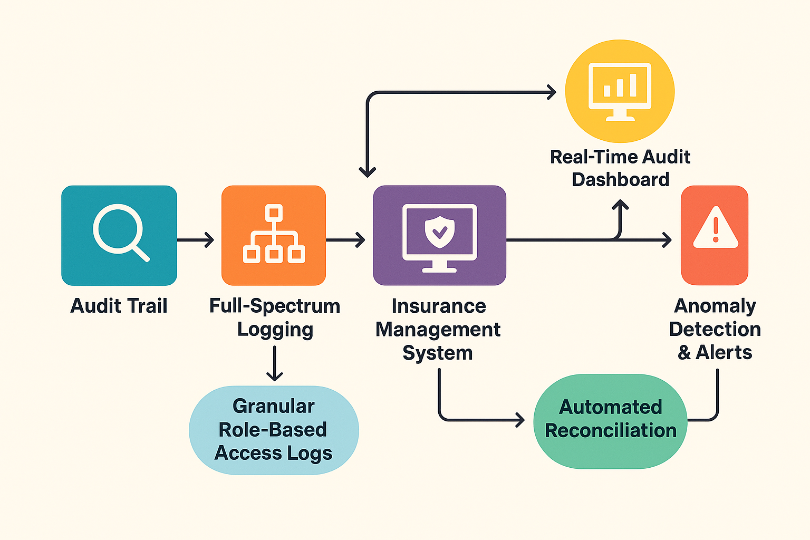

4. Functional Requirements Specification

4.1 Audit Log Viewer Page
- Purpose: View detailed logs of all transactions and user actions.
- Fields:
  - Transaction ID: Text: Unique identifier of the transaction
  - Timestamp: DateTime: Date and time of the action
  - User ID: Text: ID of the user who performed the action.
  - Module: Dropdown: IMS module where the action occurred.
  - Action Type: Dropdown: Create, Update, Delete, Override, Reversal.
  - Remarks: Text: Optional remarks or annotations
  - IP Address: Text: IP address of the user.
  - Device Info: Text: Device/browser used.
  - Status: Badge: Success, Failed, Reversed

4.2 Reconciliation Dashboard Page
- Purpose: Display real-time reconciliation status between IMS and financial systems.
- Field:
  - Date Range Selector: Allows filtering by specific periods.
  - Total Transactions: Displays count of all IMS transactions.
  - Matched Entries: Number of reconciled transactions.
  - Unmatched Entries: Number of discrepancies.
  - Discrepancy Details: List of unmatched transactions with IDs.
  - Export Option: Download reconciliation report in PDF/Excel.

4.3 Anomaly Detection Page
- Purpose: Display flagged transactions based on rule-based or ML-based anomaly detection.
- Field:
  - Alert ID: Unique identifier for each alert.
  - Transaction ID: Linked transaction reference.
  - Alert Type: Duplicate, Unauthorized Access, Reversal Pattern.
  - Severity Level: Low, Medium, High.
  - Trigger Rule: Rule or condition that caused the alert.
  - Timestamp: Detection time.
  - IP Address: IP at the time of anomaly.
  - Action Taken: Status like Pending, Investigated, Resolved.

4.4 Audit Annotation Page
- Purpose: Allow auditors to add remarks and findings to transactions.
- Field:
  - Transaction ID: Target transaction for annotation.
  - Auditor ID: Identifier of the auditor adding remarks.
  - Annotation Text: Detailed remarks or findings.
  - Date: Annotation date.
  - Status: Open, Closed, Follow-up Required.

4.5 User Access Log Page
- Purpose: Track login/logout and access patterns of users.
- Field:
  - User ID: Unique identifier for the user.
  - Role: Role assigned to the user (Admin, Auditor, Operator).
  - Login Time: Timestamp of login.
  - Logout Time: Timestamp of logout.
  - Accessed Modules: List of modules accessed during the session.
  - IP Address: Captures IP for login and actions.
  - Device Info: Browser/device details.

5. Attachments
The following documents can be referred.

